Capstone Project Title Name (24pt)

Submitted in partial fulfillment of the requirement for the award of Degree of Bachelor of Technology in
Computer Engineering (14pt)

Submitted To (12pt)


SVKM’s NMIMS,
Mukesh Patel School of Technology Management & Engineering,
Shirpur Campus (M.H.) (12pt)

Submitted By: (12pt)
Candidate Name Enrollment No – 000000000000(14pt)
Candidate Name Enrollment No – 000000000000(14pt)
Candidate Name Enrollment No – 000000000000(14pt)

Under The Supervision Of: (12pt)

Guide Name (14pt)
(Department& Designation) (14pt)

DEPARTMENT OF COMPUTER ENGINEERING (14pt)
Mukesh Patel School of Technology Management & Engineering, Shirpur (12pt)
ACADEMIC SESSION: 2026-27 (12pt)

CERTIFICATE (16pt)

This is to certify that the project entitled Project Title has been done by
“Candidate Name1” (Roll No.: 0000000001) (14pt)
“Candidate Name1” (Roll No.: 0000000002) (14pt)
“Candidate Name1” (Roll No.: 0000000002) (14pt)
under my guidance and supervision & has been submitted partial fulfillment of the degree of “Bachelor of Technology in Computer Engineering” of MPSTME, SVKM’S NMIMS (Deemed-to-be university), Mumbai (M.H.), India. [14pt]

____________ ___________
Project Mentor (12pt) Examiner (12pt)
(Internal Guide) (12pt)

Date: (12pt)

Place: Shirpur (12pt) ___________
H.O.D. (12pt)

DEPARTMENT OF COMPUTER ENGINEERING (14pt)
Mukesh Patel School of Technology Management & Engineering (12pt)
ACKNOWLEDGEMENT (16pt)

We would like to express my special thanks of gratitude to my Prof./Dr. Guide Name, Designation, Assistant Professor, Computer Engineering Department, SVKM’S NMIMS, Mukesh Patel School of Technology Management & Engineering, Shirpur Campus (M.H.), whose constant encouragement enabled us to work enthusiastically. Their perpetual motivation, patience and excellent expertise in discussion during progress of the Capstone project work have benefited us to an extent, which is beyond expression. Their depth and breadth of knowledge of computer engineering field made us realize that theoretical knowledge always helps to develop efficient operational software, which is a blend of all core subjects of the field. We are highly indebted to him/her for their invaluable guidance and ever-ready support in the successful completion of this Capstone project in time. Working under their guidance has been a fruitful and unforgettable experience.
We express our sincere thanks and gratitude to Dr. Suresh Kurumbanshi, Head of Department, Department of Computer Engineering, SVKM’S NMIMS, Mukesh Patel School of Technology Management & Engineering, Shirpur Campus (M.H.), for providing necessary resources and helps to complete the Capstone project work successfully.
We also extend my deepest gratitude to Dr. Venkatadri Marriboyina, Associate Dean, SVKM’S NMIMS, Mukesh Patel School of Technology Management & Engineering, Shirpur Campus (M.H.) for his timely support, helpful behavior and true encouraging environment to bring out the best of our endeavors.
A special mention of thanks goes to our Capstone Project Co-ordinator, Dr. Durgesh M. Sharma, Assistant Professor, Department of Computer Engineering, SVKM’S NMIMS, Mukesh Patel School of Technology Management & Engineering, Shirpur Campus (M.H.), who took time to hear, guide and keep us on the correct path so that we could draft this Project Report as per the specified guidelines. We choose this moment to acknowledge his contribution gratefully.
Finally, we sincerely wish to express my grateful thanks to all staff members of Computer Engineering Department and all those who have embedded us with technical knowledge of computer technology during various stages of our degree of Bachelor of Technology. We would like to acknowledge all my friends, who have contributed directly or indirectly in this Capstone project work.

Name of Student 1
Name of Student 2

ABSTRACT(16pt)

Approximately one page in which problem shall be defined and outline of proposed work in relation to title of the report shall be given (Times New Roman 12, 1.5 spacing)

What is Abstract?

The abstract for a project is simple, short and can be seen as an overview. It is also like a summary that defines the core of your work. Whether it is literature or science, all papers need some kind of abstract. It will also help the reader understand what you are talking about. Looking at an abstract as a summary will not just make your work easy but also help you write a good one. Always remember that an abstract is not just a summary of the whole paper but also something that could be seen as contributions/conclusions of the work done. To make the abstract more readable thing, make sure to use precise and easily understandable language.

TABLE OF CONTENTS
Sr. No. |  | Chapter No. | Page
1 |  | INTRODUCTION
 | 1.1 |  | 1
 | 1.2 |  | 2
 | 1.3 |  | 3
 | 1.4
 | 1.5
2 |  | LITERATURE SURVEY
 | 2.1
 | 2.2
3 |  | METHODOLOGY AND IMPLEMENTATION
 | 3.1
 | 3.2
 | 3.3
4 |  | RESULT AND ANALYSIS
 | 4.1
 | 4.2
5 |  | ADVANTAGE, LIMITATIONS AND APPLICATIONS
 | 5.1
 | 5.2
 | 5.3
6 |  | CONCLUSION AND FUTURE SCOPE
 |  | References
 |  | Appendix A: Sample code
 |  | Appendix B: Data sheets
 |  | Appendix C: List of components
 |  | Appendix D: List of paper presented and published

LIST OF FIGURES

Sr. No. | Figure No. | Name of Figures | Page
1
2
3

LIST OF TABLES
Sr. No. | Table No. | Name of Table | Page
1
2

Chapter 1
Introduction

Introduction (of the project, and the flow of different chapters)
1.1 Background of the project topic
1.2 Motivation and scope of the report
1.3 Problem statement
1.4 Salient contribution
1.5 Organization of report

Note:
1. Please include the citations for the papers referred and also include it in the
references at the same numbered location as in the text.

Chapter 2
Literature survey

Discussion and comparison of literature survey.
2.1 Introduction to overall topic (generate background for literature survey with
reference to minimum 15 references)
2.2 Exhaustive literature survey of at least 10 good journal or conference papers
related to topic preferably starting from reference 1 to 15 given in the reference section serially. Literature survey should lead finally to identifying the gap in the research area and hence definition of problem statement.
Note:
1. Please include the citations for the papers referred
2. Include it in the reference list at the same location as the number in the
text.
What is a literature review?
A literature review summarizes and synthesizes the existing scholarly research on a particular topic. Literature reviews are a form of academic writing commonly used in the sciences, social sciences, and humanities. However, unlike research papers, which establish new arguments and make original contributions, literature reviews organize and present existing research. As a student, you might produce a literature review as a standalone paper or as a portion of a larger research project. Literature Review should be written in paragraph pattern in report and in comparative form in presentation.

Chapter 3
Methodology and Implementation

3.1 Block diagram
3.2 Hardware description
3.3 Software description, flowchart / algorithm

This chapter can comprise of actual implementation photos and their description.

Chapter 4
Results and Analysis

This shall include a thorough evaluation and investigation carried out. It should also bring out your contributions from the study. The discussion shall logically lead to inferences and conclusions as well as scope for possible further future work.

Chapter 5
Advantages, Limitations and Applications

5.1 Advantages
5.2 Limitations
5.3 Applications

Chapter 6
Conclusion and Future Scope

- A brief report of the work carried out, conclusions derived from logical analysis presented in the Results and Discussions chapter.
- Scope for future work should be stated lucidly in this chapter.

References
- Number all the references.
- Use a chronological bibliography.
- Each listed reference in the bibliography must be cited in the text of the report.
- For a book give the name(s) of author(s), title of book, edition, chapter number, and page numbers, publisher, location and year of publication.
- Example:
[25] Jones, C.D., A.B. Smith, and E.F. Roberts, Efficient Real-Time Fine-Grained Concurrency, 2nd Ed., Ch. 3, pp. 145-7, Tata McGraw- Hill, New Delhi, 1994.
- For a journal/conference paper, give the name(s) of authors, title of paper, name of journal/ conference, volume and issue number (for journal), page numbers, and month and year of publication.
- Example:
[23] Prasad, A.B., Kumar, C.D., Jones, E.F., and Frost, P.: “Cable Television Broadband Architectures”, IEEE Comm. Magazine, vol. 39, pp. 134-141, June 1991.

Appendix A: Sample code

Appendix B: Data Sheets

Appendix C: List of Components

Appendix D: List of Paper Presented and Published

Rules for Writing Black Book Report

(This page is only for reference and should not be included in the
final report)

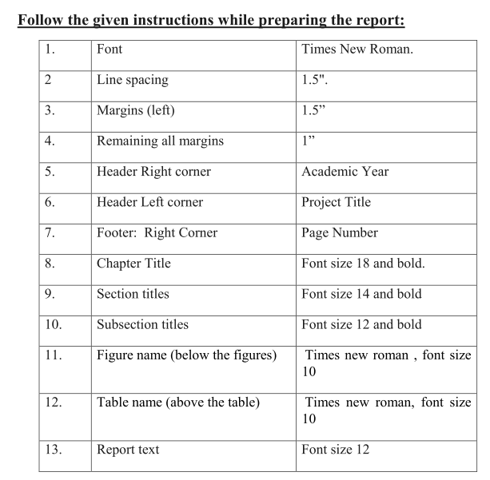
14. Appendix will include:
- Specifications of components
- Pin diagram
- Source code
- Sample codes
- Raw experimental observations etc.
- which shall be numbered in Roman Capitals (e.g. “Appendix IV”).

15. The report (N+1 Copies) should be Hard Bound- Black Book
16. The report must be verified and signed by the respective mentors before the
final Presentation / examination.
17.Refer to the following table of contents for the format.
18.Page numbers in Table of Contents for List of Figures, List of Tables and Abbreviations has to be in Roman numbers.
19. Page numbers from Chapter 1. Introduction, onward should be in decimal
format.
20. Every chapter should have introduction paragraph and summary lines.
21. Conclusion will be only one, which will be written at the end of report.

